Houston County
Office of Emergency Management
& Fire Marshal
600 Bradshaw Crockett, Texas 75835
Phone (936) 544 - 7175 Fax (936) 544 - 7956
“SAVE OUR SENIORS TEXAS”
Governor Greg Abbott has announced that the Texas Division of Emergency (TDEM), the Texas Department of State Health Services (DSHS), and the Texas Military Department (TMD) has named Houston County as a participating county in the
“Save Our Seniors” initiative.

This is the most recent plan to protect our citizens of Houston County.
The shot is FREE and Vaccination Center will be at The Crockett Civic Center @ 1100 Edmiston Drive, Crockett, TX for qualified recipients listed below.
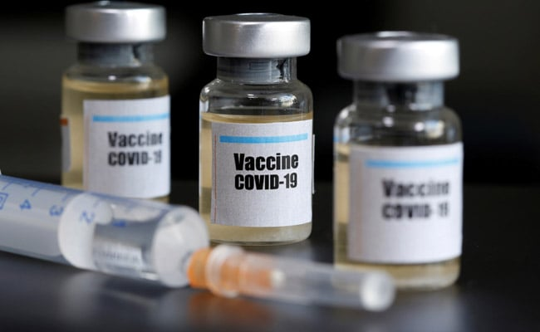

500 doses of Moderna,

Administered by Military Team on Thursday and Friday, March 18^{th,} & 19th, 2021 from 8am-4pm

Anyone 50 and older along with household family members (21 & older) and or care givers. Also including Education Employees. CALL 936-544-7175 Wednesday, March 17th between noon and 5pm If you have questions or need to schedule a home visit for a home bound patient. Registration on-site

